Problem 1:
Entity:
- Room: room_code, room_name, room_price_per_day, room_price_per_week, floor_code
- Floor: floor_code, floor_name
- Guest: guest_code, guest_fullname, guest_phone
- Service: service_code, service_name, service_amount
- Invoice: invoice_code, invoice_ arrival_date, invoice_departure_date, invoice_room_amount, invoice_ service_amount, invoice_ total_amount, guest_code, room_code.
- Invoice_Service: invoice_service_unit, invoice_service_total, invoice_code, service_code
Relationship:

- Room – Floor: (N, 1).
- Room – Guest: (1, N)
- Invoice – Service: (M, N)
- Room – Invoice: (N, 1).
- Guest – Invoice: (N, 1)

ER:
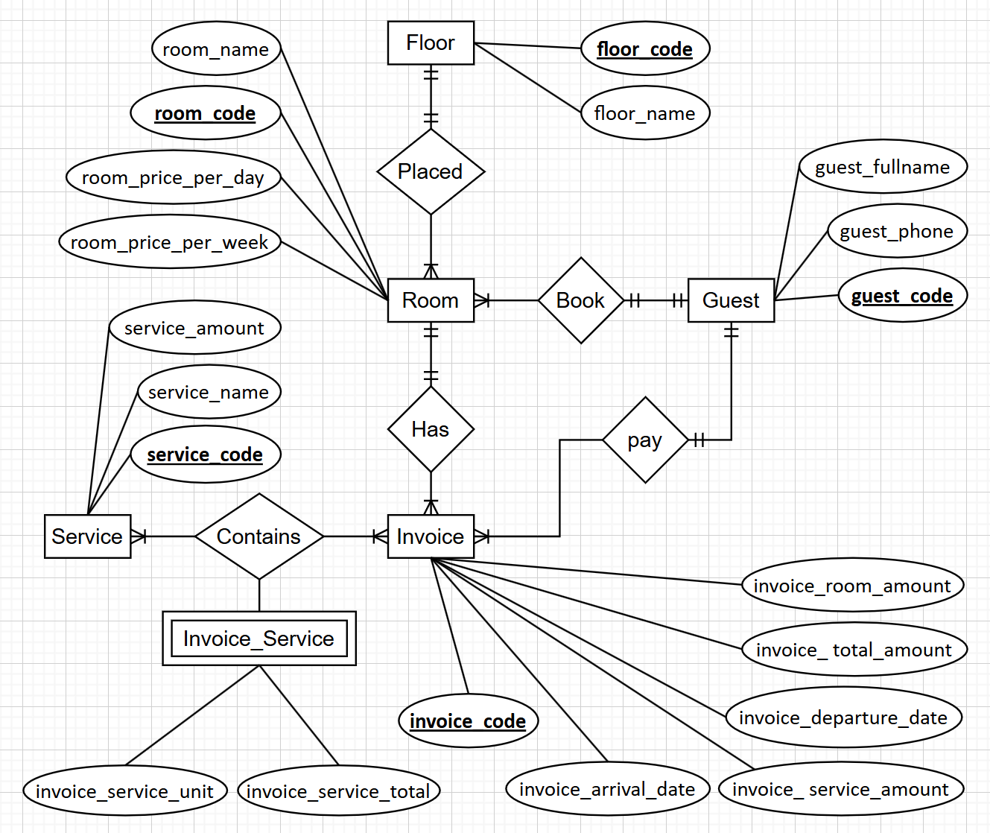
Canonical Cover:
- Room:
  - room_code → room_name
  - room_code → room_price_per_day
  - room_code → room_price_per_week
  - room_code → floor_code
- Floor:
  - floor_code → floor_name
- Guest:
  - guest_code → guest_fullname
  - guest_code → guest_phone
- Service:
  - service_code → service_name
  - service_code → service_amount
- Invoice:
  - invoice_code → invoice_arrival_date
  - invoice_code → invoice_departure_date
  - invoice_code → invoice_room_amount
  - invoice_code → invoice_service_amount
  - invoice_code → invoice_total_amount
  - invoice_code → guest_code
  - invoice_code → room_code
- Invoice_Service:
  - (invoice_code, service_code) → invoice_service_unit
  - (invoice_code, service_code) → invoice_service_total
Problem 2:
- Find employees who work in room 4.
$$Π_{employeeID, fullname}(σ_{departmentID=4}\left(employees⨝department\right)$$
$$another way: σ_{departmentID=4}\left(employees\right)$$
- Find employees with salaries above 30000.
$$Π_{employeeID, fullname}(σ_{salary>30000}(employees)$$
- For each department, indicate the department name and room location.
$$Π_{departmentName, address}(department⨝departmentAddress)$$
- The average salary of all female employees.
$$g_{avg\left(salary\right) as average_salary}(σ_{gender=^{'}Nu^{'}}\left(employee\right))$$
- Find the names and addresses of all employees of the "Nghien Cuu" department.
$$Π_{fullname, address}(σ_{departmentName=^{'}Nghien Cuu^{'}}(employees⨝department)$$

